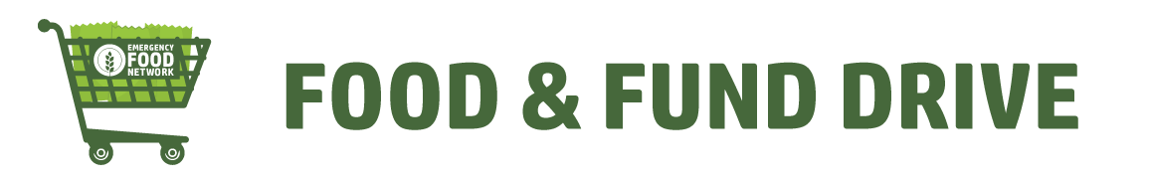
Greetings friends and family,
Food insecurity is a huge concern in our community, 1 in 10 individuals in Pierce County experienced food insecurity. This means that those people didn’t know where their next meal or their children's next meal would be coming from. Visits to food pantries continue to grow each year and with cuts to enhanced programs like SNAP, there is no relief in sight. While it may feel like the need is insurmountable, we have the tools to make a real impact on hunger in our community.
I/my organization am/is hosting a Virtual Food Drive in support of Emergency Food Network (EFN) to help feed our neighbors in need. EFN procures and distributes 14 million pounds of food to 75+ food pantries in Pierce County. Your donations will allow EFN to purchase food in bulk, solicit food donations, and transport food to pantries.
This is important to me/my organization because add a personal message here.
My goal is to raise $______ for Emergency Food Network, so that no person goes hungry.
DONATE HERE: EFN will provide a personalized link to track your donations and will update you weekly with donation totals!
For every $1 donated, EFN can distribute 2 meals to our neighbors in need.
Thank you for your support!

